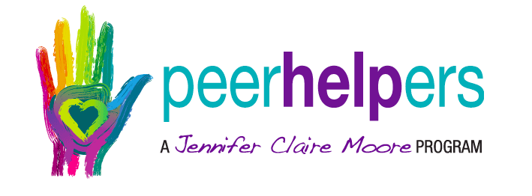

CBMS 2022-2023 Peer Helpers

8th grade: 7th grade:

Conner Cruthird Thomas Manning

Bella Menicucci Wyatt Gipson

Reese Murrell Cameron Shaver

Madelyn Biggs Lilly Beasley-King

Sydney Gregson John Christian Lee

Cayden Childress Isabella Rider

Brantley McGilvray Rhilynn Duncan

Noah McDaniel Kason Weaver

Ashton McKey

Coordinator: Mitzi Lohn

Coordinator: [Nancy McAllister](mailto:nmcallister@ibaldwin.org)

Counselor: [Lana Mallett](mailto:lmallett@ibaldwin.org)